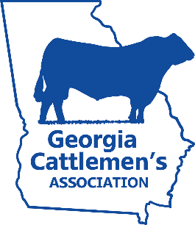
2022 JUNIOR CATTLEMAN OF THE YEAR AWARD

Name: _______________________________________ GJCA Member #: ___________________________
Farm or Ranch Name: _____________________________________________________________________
Address: ___________________________________________________________________________________
City: _______________________________ State: ________________________ ZIP: ____________________
Phone: ______________________________ Email: _______________________________________________
Cattlemen’s Chapter: ______________________________ # of years in GJCA: ___________________
Birthdate: __________ /__________ /__________
Please answer the following questions. If additional space is needed, attach pages to this application.

Explain your interest in the agriculture industry.
___________________________________________________________________________________________________________________________________________________________________________________________________________________________

Explain your interest in the cattle industry.
___________________________________________________________________________________________________________________________________________________________________________________________________________________________

What are your career goals?
___________________________________________________________________________________________________________________________________________________________________________________________________________________________

Please explain how you have supported or participated in events hosted by your local GCA chapter such as educational programs, chapter meetings, community events, etc.
___________________________________________________________________________________________________________________________________________________________________________________________________________________________

List awards, scholarships and other honors relative to agriculture:
___________________________________________________________________________________________________________________________________________________________________________________________________________________________

** The winner of this award will be announced at the Cattlemen’s Ball at the Georgia Cattlemen’s Association Convention & Trade Show and Annual Beef Expo. The winner will be awarded a commemorative belt buckle and be recognized at the Ball with a feature video and will receive a feature story spread in the Georgia Cattleman Magazine.

Application is due to the Georgia Cattlemen’s Association by January 6, 2023.
Mail application to: Georgia Cattlemen’s Association
Attn: Junior Cattleman of the Year Award
P.O. Box 27990
Macon, Georgia 31221

Or email application to: taylor.pearce@gabeef.org

