Georgia Cattlemen’s Association County Agent of the Year Beef Award
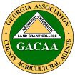

2021 Award Application

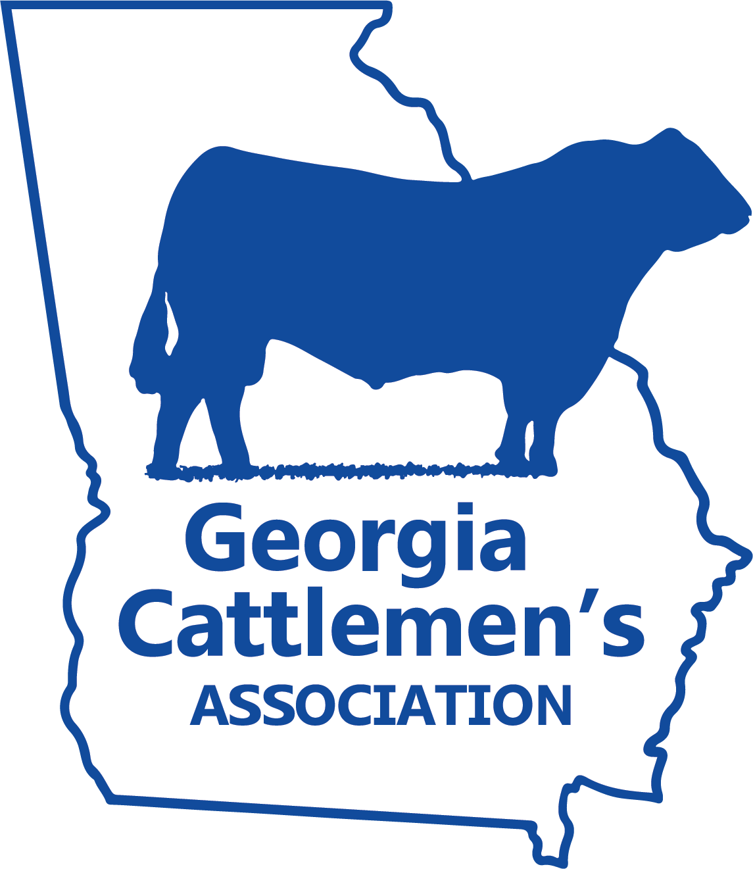

Revised: 07/14/21

Name
Address: |  | County:
Town: | Georgia | Zip Code:
Phone #: | Cell #: | FAX #:

GACAA District
Northeast | Northwest | Southeast | Southwest | State Staff

My signature verifies that I am a paid-up member of GACAA and have read and understood the rules and certify that my entry meets those requirements.

My employment date was

Number of years in county

Signature _Date
(I certify I am currently a member in good standing of GACAA)

Recipient must attend GACAA Annual Meeting/Professional Improvement Conference to receive award, unless exempted by GACAA President because of extenuating circumstances. (Established by GACAA Board action, November, 2008)

Include Entry Form, Four-Page Summary, Letter from Supervisor and Letter of Recommendation from local Georgia Cattlemen’s Association Chapter President in application package. Entries for the Award must be submitted by December 1, 2021.

Mail to: Georgia Cattlemen's Association Agent contact: Justin Hand
P. O. Box 27990 jhand@uga.edu
Macon, GA 31212

