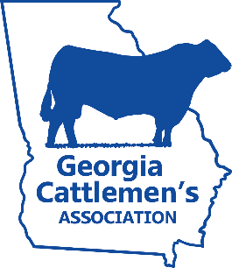
2021 JUNIOR CATTLEMEN OF THE YEAR

Name: _______________________________________ GJCA Member #: ___________________________
Farm or Ranch Name: _____________________________________________________________________
Address: __________________________________________________________________________________
City: _______________________________ State: ________________________ ZIP: ____________________
Phone: ______________________________ Email: ______________________________________________
Cattlemen’s Chapter: ______________________________ # of years in GJCA: ___________________
Birthdate: __________ /__________ /__________
Please answer the following questions in the space allotted. Additional pages will not be accepted.
Briefly describe the GJCA activities you have been involved with:

What does GJCA mean to you?

Explain your interest in agriculture:

Explain your interest in the cattle industry:

What are your career goals?

List awards, scholarships and other honors relative to agriculture:

This completed application is due to the Georgia Cattlemen’s Association office no later than Dec. 1, 2021. Applications may be either emailed or mailed to the office.
Mail applications to:
Taylor Pearce
Georgia Junior Cattlemen’s Association
PO Box 27990
Macon, GA 31221
Or via email at taylor.pearce@gabeef.org

The winner of this award will be announced at the Cattlemen’s Ball at the Georgia Cattlemen’s Association Convention & Trade Show and Annual Beef Expo. The winner will be awarded a commemorative belt buckle and be recognized at the Ball with a feature video and will receive a feature story spread in the
Georgia Cattleman Magazine.

